Name: ___________________________________________ Period: ________ Date: _________

Unit | Human Impacts on the Environment | Environmental Geography
8 | Human Impacts on the Environment | Environmental Geography

The following information corresponds to Chapter 34 in your textbook. Fill in the blanks to complete the definition or sentence. Note: All of the following information in addition to your reading is important, not just the blanks you fill in.

Atmosphere
- The atmosphere is a largely __________ resource.
- Global ___________ could be around 3.5°F – 5.5°F over the next 50 years; in March, 2002, a _______ ________-sized chunk broke off Antarctica!
- ____________ gases are increasing at a rate of 2% per decade (CO2, methane, nitrous oxides,…)
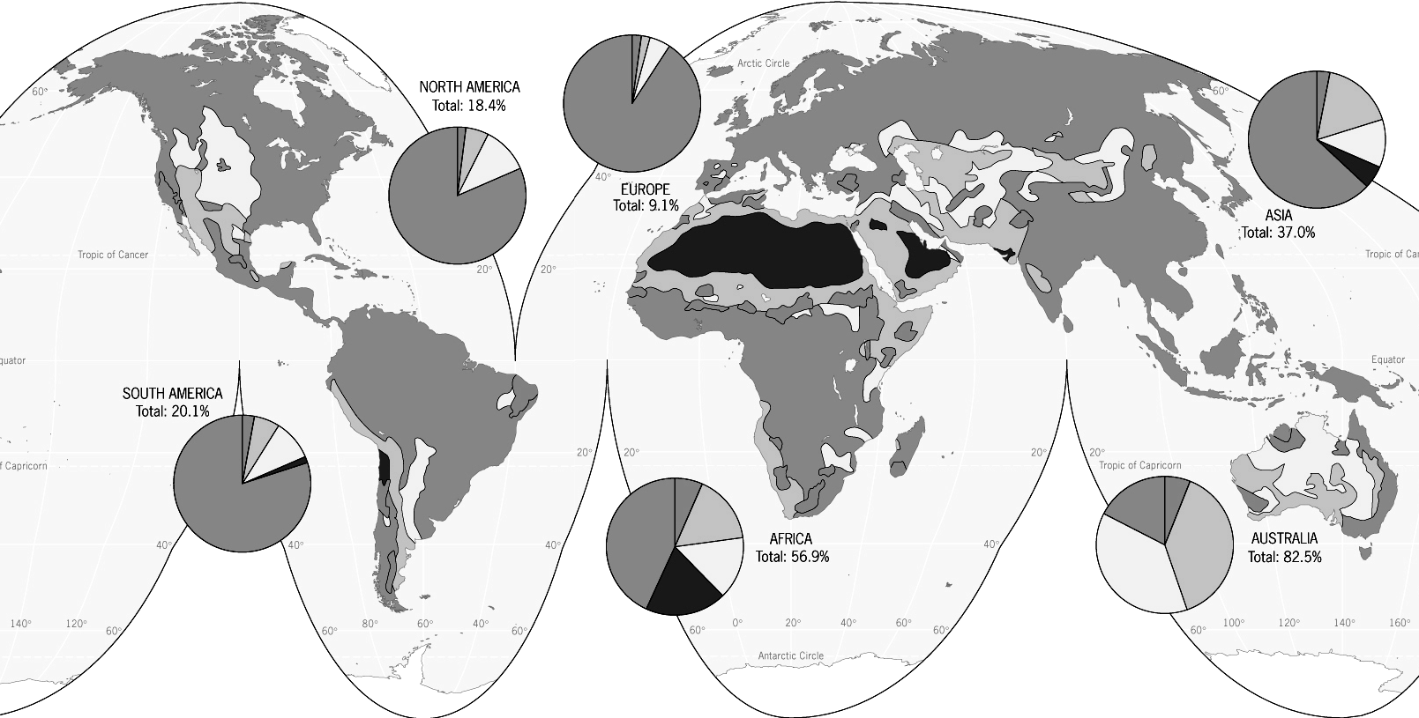
- ______ rain is caused by the burning of fossil fuels (coal, oil, natural gas); emitted by cars, industries,…; it can be _________ enough to do great damage over time; e.g. acidification of lakes, stunting of forests, loss of crops & fish,…

The Land
- ______________ is cyclic; the Sahara alone has lost 270,000 sq. mi. of non-desert land over the past 50 yrs.; accelerated by overgrazing, woodcutting, soil exhaustion,…
- In the 1980s, the Food & Agriculture Organization (FAO – part of the UN) studied the effects of ______________; determined that 44% of global tropical rainforests are already affected by cutting.
- 1% logged is every year; at this rate the entire equatorial forest would be gone in less than ____ yrs.
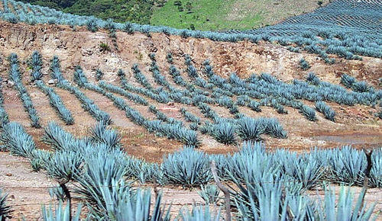
Soil Erosion in Mexico
- Forests convert CO2 to ________; counteract oxygen loss & greatly affect the oxygen cycle.
- ______ __________ has been a “quiet crisis;” ____________ pressure has been a major cause – as agricultural land use intensifies, water & wind _________ increases.
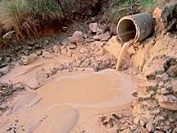
- Soil is a ____________ resource, but >25 billion tons of it is lost per year.

Waste Disposal
- The U.S. is the largest producer of ________ waste (3.7 lbs. per person per day); containers, packaging, etc…
- ______ regions (US, EU, Japan) export solid waste to the periphery.
- __________ landfills: prepared areas for waste disposal (includes a floor of materials to treat seeping liquids).
- Poorer countries: have open garbage dumps, decomposition sends methane into air (acid rain), contaminants seep into groundwater.


Hazardous Materials

- ________ waste: danger is caused by chemicals, infectious materials, …
- Radioactive waste:
- ______-level: give off small amounts of radiation – hospitals, research facilities, nuclear power plants are the main sources of these minor contaminants.
- _______-level: nuclear power plants & nuclear weapons facilities; may cause massive pollution and contamination.
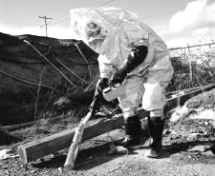
- There is no satisfactory means of disposing _______-level radioactive waste (e.g. salt effectively blocks some radiation).

Biodiversity
- There are between ___ - ____ million species in the world today.
- Only around ______ million species have been identified.
- ________ travel has introduced new species worldwide, and has threatened many species (e.g. Colombian exchange).
- The combination of human population pressure, technology & economic forces lead to _________ endangerment & extinction.
- Examples of mankind’s affect on the animal kingdom:
  - _______ bird: hunted to extinction – Mauritius (in the Indian Ocean); the primary causes of their extinction were the destruction of the ________ (which cut off the Dodo's food supply), and the animals that the ________ sailors brought with them, including cats, rats, and pigs, which destroyed Dodo nests; the last known Dodo bird was killed in ______.
  - The American ________ dominated the mid-west landscape; less than ______ of them remained in the U.S. and Canada by the turn of the century out of the millions that once lived there; through massive protection efforts – today about _________ exist in herd today.
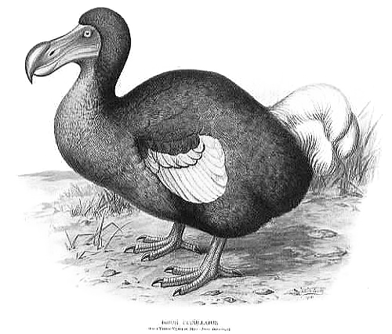
  - ___________ pigeon: the last captive one died in the Cincinnati Zoo (1914)


